Marriage of one Lewis Mordaunt. 1690
https://archive.org/details/allegationsforma3031chur/page/146
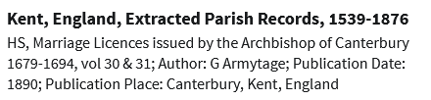
146pg - Marriage Allegations in the Registry of Vicar-General of the Archbishop of Canterbury.
18 June 1690

Also
https://www.findmypast.co.uk/transcript?id=GBOR/OR/AOR/00011922
